Project 1

Lucas Myers

CIS 457

Successful Request/Response Interaction

Images on next page

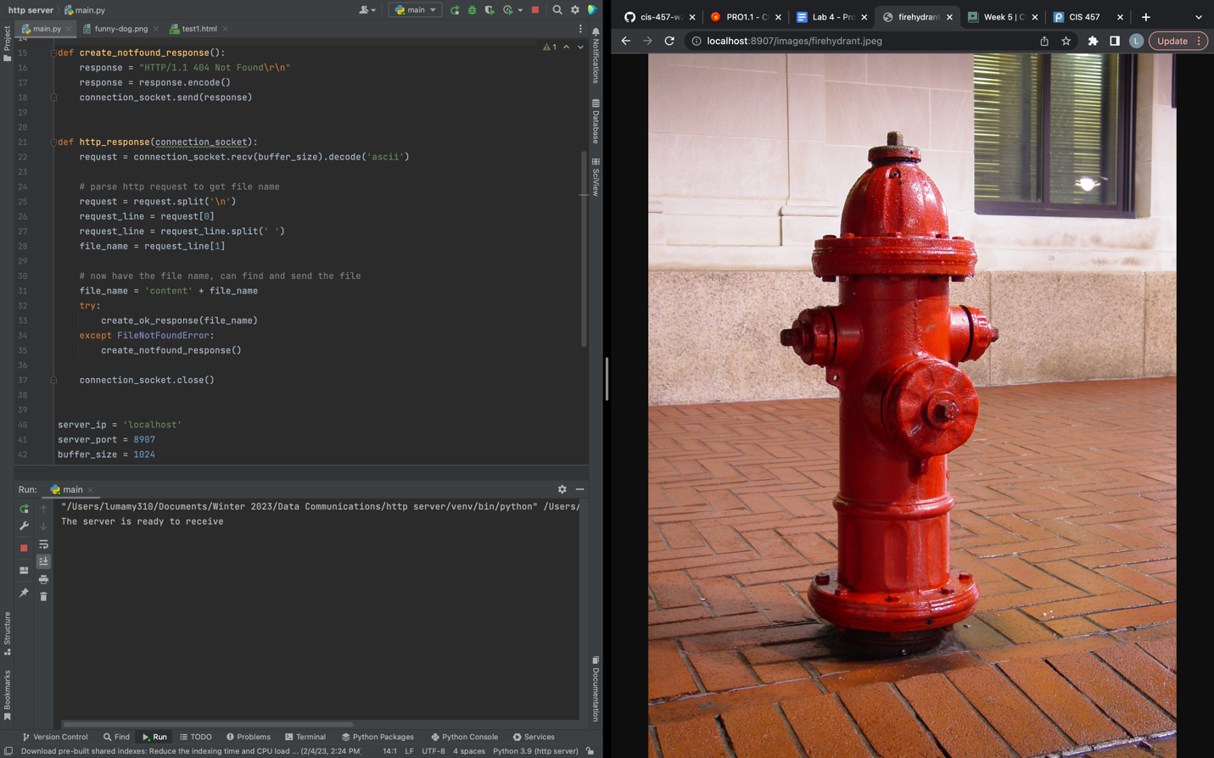

Basic Logic

import socket  
import threading  
  
  
def create_ok_response(file_name):  
 response = "HTTP/1.1 200 OK\r\n" \  
 "\r\n"  
  
 with open(file_name, 'rb') as f:  
 file = f.read()  
 response = response.encode() + file  
 connection_socket.send(response)  
  
  
def create_notfound_response():  
 response = "HTTP/1.1 404 Not Found\r\n"  
 response = response.encode()  
 connection_socket.send(response)  
  
  
def http_response(connection_socket):  
 request = connection_socket.recv(buffer_size).decode('ascii')  
  
 # parse http request to get file name  
 request = request.split('\n')  
 request_line = request[0]  
 request_line = request_line.split(' ')  
 file_name = request_line[1]  
  
 # now have the file name, can find and send the file  
 file_name = 'content' + file_name  
 try:  
 create_ok_response(file_name)  
 except FileNotFoundError:  
 create_notfound_response()  
  
 connection_socket.close()  
  
  
server_ip = 'localhost'  
server_port = 8907  
buffer_size = 1024  
  
welcome_socket = socket.socket(socket.AF_INET, socket.SOCK_STREAM)  
welcome_socket.bind((server_ip, server_port))  
  
welcome_socket.listen()  
  
print('The server is ready to receive')  
  
while True:  
 connection_socket, addr = welcome_socket.accept()  
 threading.Thread(target=http_response, args=(connection_socket,)).start()

The largest challenge of this project was implementing the sending of images. This was solved by opening all files in binary and sending them in one send. I tried using chunks, but the browser would only load the first chunk into the image. To resolve this, I removed the chunk loop and replaced it with a single send command.

Getting the 404 response was straightforward. When python cannot open a file, it gives a FileNotFound error. I placed the response method in a try/catch block to determine if a 200 OK or 404 error should be sent.